Computer system lab 2
Name: Nur E Siam
Roll: 103842784
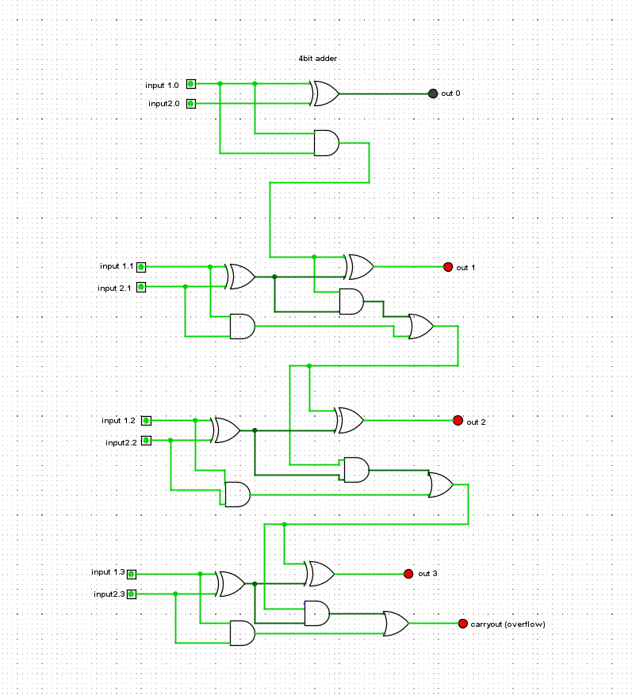
Fig:1

Table:1
Input A | Input B | Output
0101 | 0000 | 0101
0101 | 0001 | 0100
0101 | 0010 | 0111
0101 | 0011 | 0110
0101 | 0100 | 0011
0101 | 0101 | 0010
0101 | 0110 | 0000
0101 | 0111 | 0001
0101 | 1000 | 1101
0101 | 1001 | 1100
0101 | 1010 | 1111
0101 | 1011 | 1110
0101 | 1100 | 1011
0101 | 1101 | 1010
0101 | 1110 | 1000
0101 | 1111 | 1001

Fig: 2
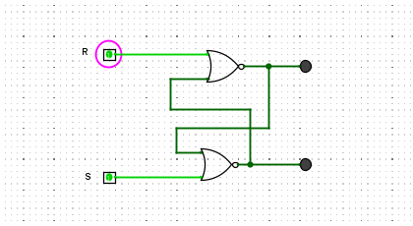
Table:2
SET | RESET | Q | Q’
1 | 0 | 0 | 1
1 | 1 | 0 | 0
0 | 1 | 1 | 0
1 | 1 | 0 | 0

Fig:3

Table: 03
Clock | Pin | Q | Q
0 | 0 | 1 | 0
0 | 1 | 1 | 0
1 | 1 | 0 | 1
1 | 0 | 0 | 1

Fig : 4
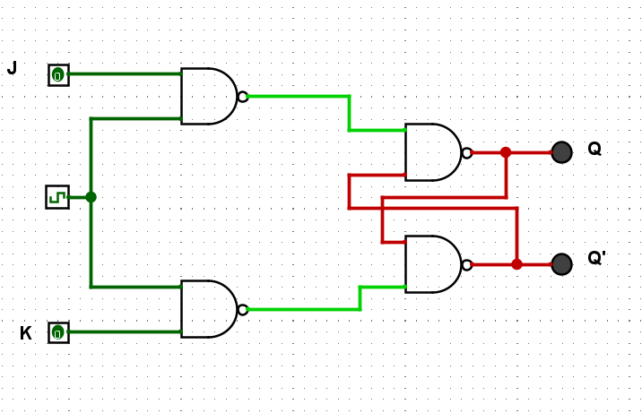
Table: 4
J | K | Q ( When clocked) | Q’( when clocked)
0 | 0 | No Change | No Change
1 | 0 | 1 | 0
0 | 1 | 0 | 1
1 | 1 | Toggle | Toggle

